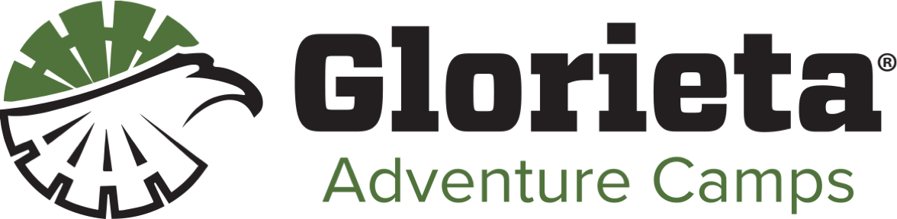
Clothing
We do not provide the means to machine wash or dry clothes
● T-Shirts – Bring several that you don’t mind getting dirty. We will get messy each day, please bring clothes that can get messy. We will have a luau one night, dress the part.
● Shorts – Bring athletic/hiking shorts that you don’t mind getting dirty and are long enough to feel comfortable in a harness.
● Shoes – Closed-toe shoes for activities and flip flops for the Dorm and shower area –remember they might get dirty!
● Socks and Underwear - Bring plenty!
● Rain Jacket or Poncho
● Hat / Bandana
● Jacket / Long Sleeves / Jeans / Long Pants – It’s cold in the mornings and evenings!
● Water bottle – 32 oz size suggested
● Flashlight or Headlamp
● Backpack
● Sunscreen
● Insect Repellant (optional)

Dorm Specific
● Pillow and Bedding - XL twin size or sleeping bag
● Toiletries – toothbrush, toothpas/twote, shampoo,
conditioner, deodorant, soap...the usual
● Towels – One/two for the shower and one for the lake if you’ll be
swimming
● Hand Towel / Washcloths
● Fan (optional)

Do Not Bring
- ● Knives, Firearms, Fireworks or Anything Sharp
- ● Pets
- ● Alcohol, Drugs, or Tobacco Products – this includes e-cigarettes

We exist to Inspire Christ-like change through outdoor adventure, authentic relationships, and Biblical truth.

