The Wheel represents a God-glorifying life.
- When you look at a wheel in motion you only see the hub (Jesus) and outer rim (the fruit of our life as an obedient, active Christian)
- And though you cannot see them when in motion, the spokes are what give support and stability.
- The Vertical Spokes represent how we relate to God through Scripture and Prayer
- The Horizontal Spokes represent how we relate to Others (in Community and through Missions)

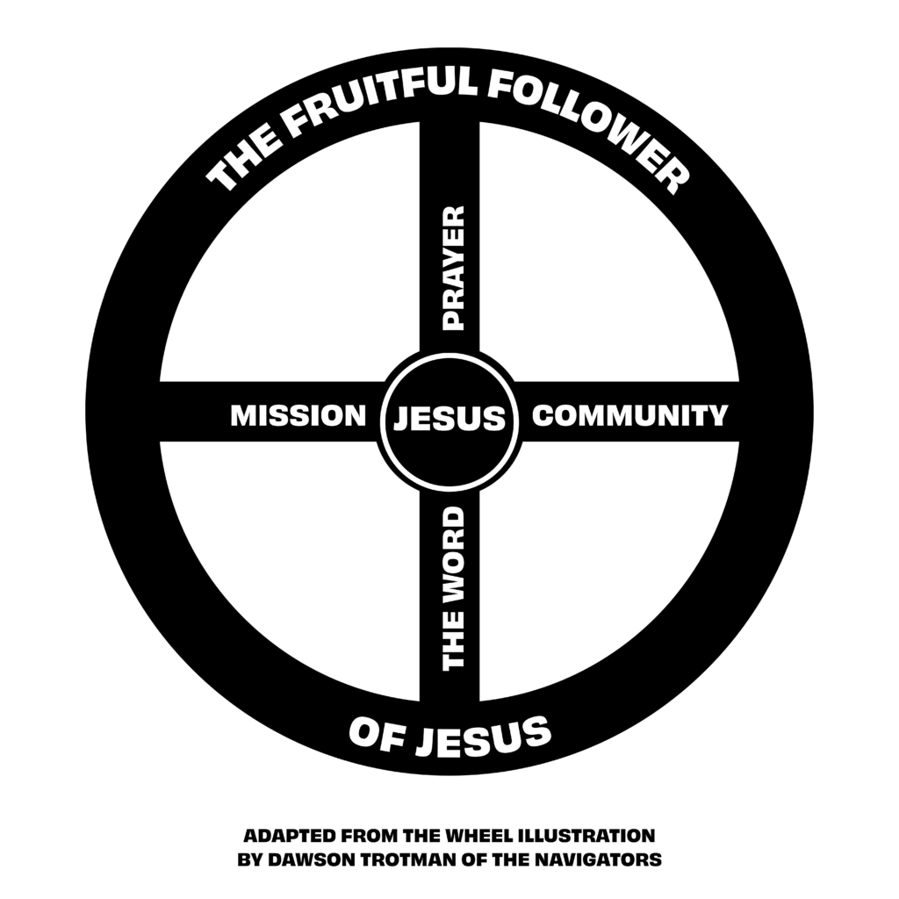
- THE CENTER HUB - CHRIST
A Christ Follower always keeps Jesus at the Center of their life
Total surrender to Christ’s authority and lordship is not always a decision made right at conversion, but is a necessary act of will. For the believer, the “old life” has gone and the new has come (2 Corinthians 5:17), and Christ has begun to dwell in us (Galatians 2:20). God creates within us the desire to do what He wants us to do in order to express His Lordship in our lives.
- VERTICAL SPOKE - THE WORD
A Christ Follower makes engaging God’s Word a daily priority as a means to know and engage with God himself.
God uses His word to speak directly to us, revealing not only who He is, but how He calls us to live and interact with everyone around us (2 Timothy 3:16). This means an earnest personal intake of God’s Word is essential for our spiritual health and growth (Joshua 1:8). As God speaks to us through the Scriptures, we learn how to obey Him and apply the gospel to every part of our lives. We also come to know Jesus personally and find He is worthy of our steadfast allegiance.

- VERTICAL SPOKE - PRAYER
Prayer is the natural response to God as we hear Him speak through His Word.
It is sharing our heart with the One who longs for our companionship and who cares about our concerns. Prayer not only trains our hearts and minds to know the power and glory of God, but also turns His ear towards action in our lives (John 15:7, Philippians 4:6-7).

- HORIZONTAL SPOKE - COMMUNITY
A Christ Follower prioritizes relationships with other believers by meaningfully connecting to a local church. This includes corporate worship experiences, small groups and discipleship relationships.
God has directed Christians to build each other up through interdependence and loving relationships with each other (Hebrews 10:24-25). Gathering together as the Body of Christ draws God close around us as we praise Him and encourage one another (Matthew 18:20).
LEARN MORE ABOUT GROUP LIFE HERE

- HORIZONTAL SPOKE - MISSION
A Christ Follower seeks to share the gospel of Jesus Christ with others
God has given believers the joy and responsibility of telling the world about the good news of Christ’s work on Earth (Matthew 4:19). In fact, sharing about His amazing grace is the natural overflow of a rich, vibrant life in Christ (Romans 1:16)
LEARN MORE ABOUT SHARING YOUR FAITH HERE

- THE OUTER RIM - THE FRUITFUL FOLLOWER OF CHRIST
The spokes of a wheel in motion aren’t visible but the hub and rim are. The outer rim of a Christ Followers life is the fruit others see that is a result of one’s obedience and pursuit of Jesus.
Some acts of obedience to God are internal, such as attitudes, habits, motives, values and day-to-day thoughts. But even these eventually surface outwardly in our relationships with other people. Keeping His commands in obedience is our outward indication of inward health and love for Christ (John 14:21, Romans 12:1).

Go more in depth and find scripture links, etc be scanning here:


